Gospel Transport Prayer Letter

June, 2023

Dear Co-laborers, Partners in Christ,

I Corinthians 3:9 "For we are labourers together with God: ye are God's husbandry, ye are God's building."

The two ongoing projects are: 1. The flea market outreach, and 2. 'SAVE THE CHILDREN'. We distribute Biblical scripture year round and God has allowed us to reach several thousand children with the message that Christ is the Savior of all who accept Him just as they are. We need to pray that our printer will last long enough to supply scripture in the near future and be gotten into the hands and hearts of these little souls.

It's truly a blessing that we're able to distribute @ 25,000 portions of God's Word at the Alamo flea market monthly. We're also supplying others in Brownsville and McAllen, TX. (Some of the largest markets this side of the border plus others further into Mexico.) We've been blessed to average one semi load of scripture each month into different locations. Our last shipment was received in Guatemala the 30th of May. We're planning a shipment to Nicaragua very soon. We ship a number of small loads across the border into Latin America. How God is blessing!

Continue to pray for urgently needed whole Spanish Bibles, children's outreach literature, Gospel tracts, John & Romans (English and Spanish). Please pray for Bro. Jack Ferguson who'll be going to Guatemala with a missionary whom we are blessed to supply Gospel literature to. He will meet with different missionaries and international pastors to establish a Bible distribution center there. Our hope is to ship two containers of Scripture to them per year.

Other prayer requests: soul's salvation, our nation, our armed forces, one another, our health, road safety, finances, Bro. Jack's field trip, the Scriptures.

John 4:35 "Say not ye, There are yet four months, and then cometh harvest? behold, I say unto you, Lift up your eyes, and look on the fields; for they are white already to harvest."

THANK YOU FOR YOUR PRAYERS AND FINANCIAL GIFTS WHICH MAKE ALL THIS POSSIBLE!

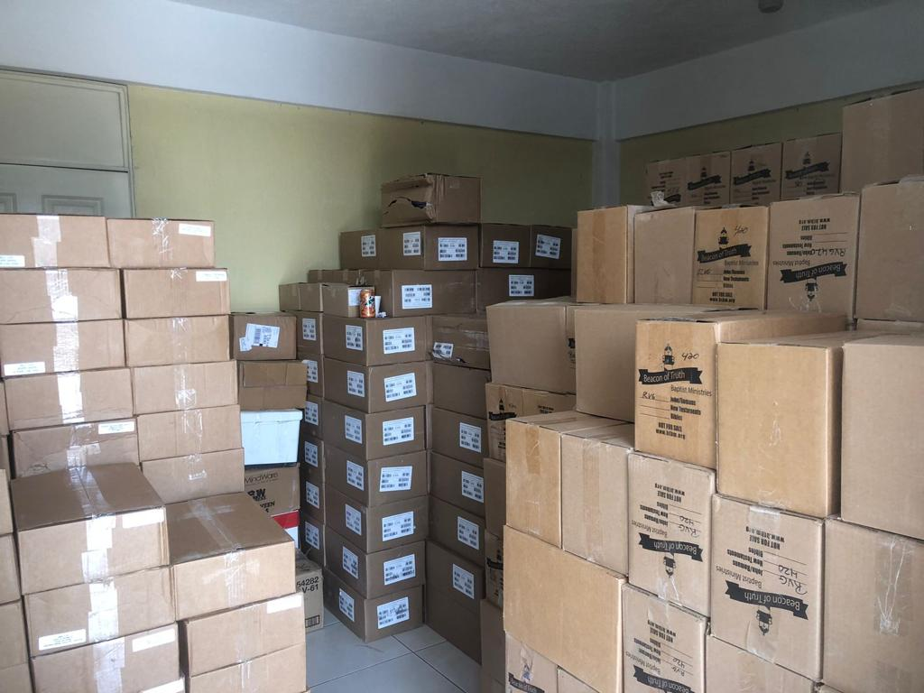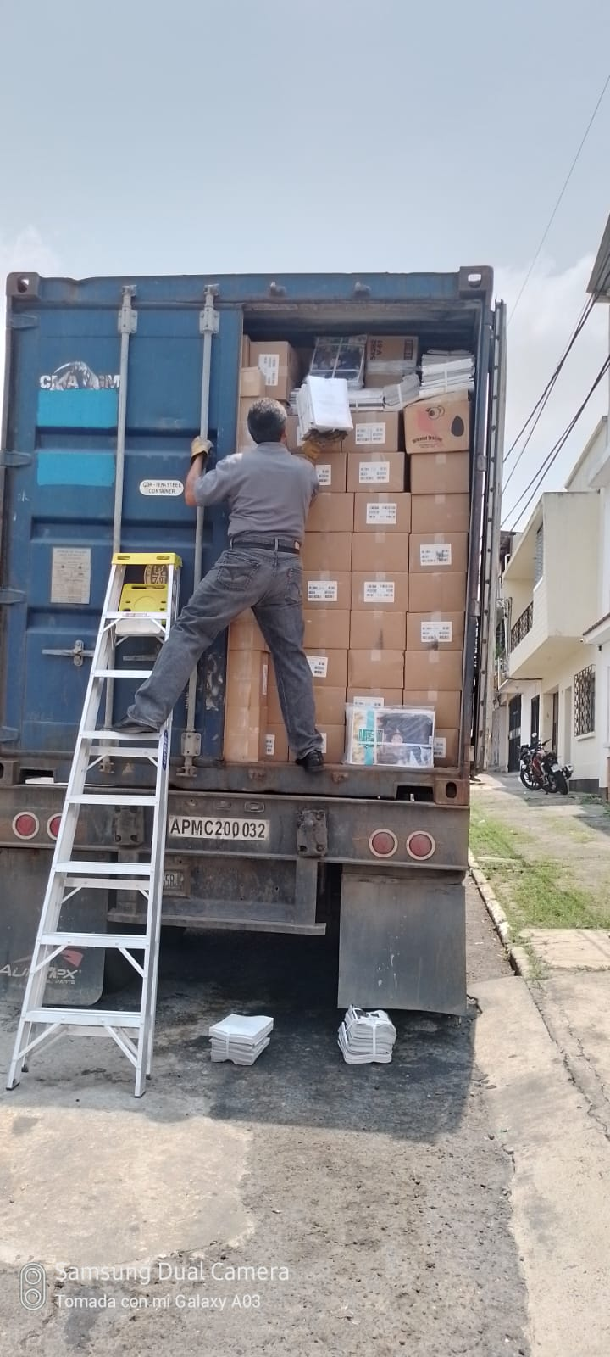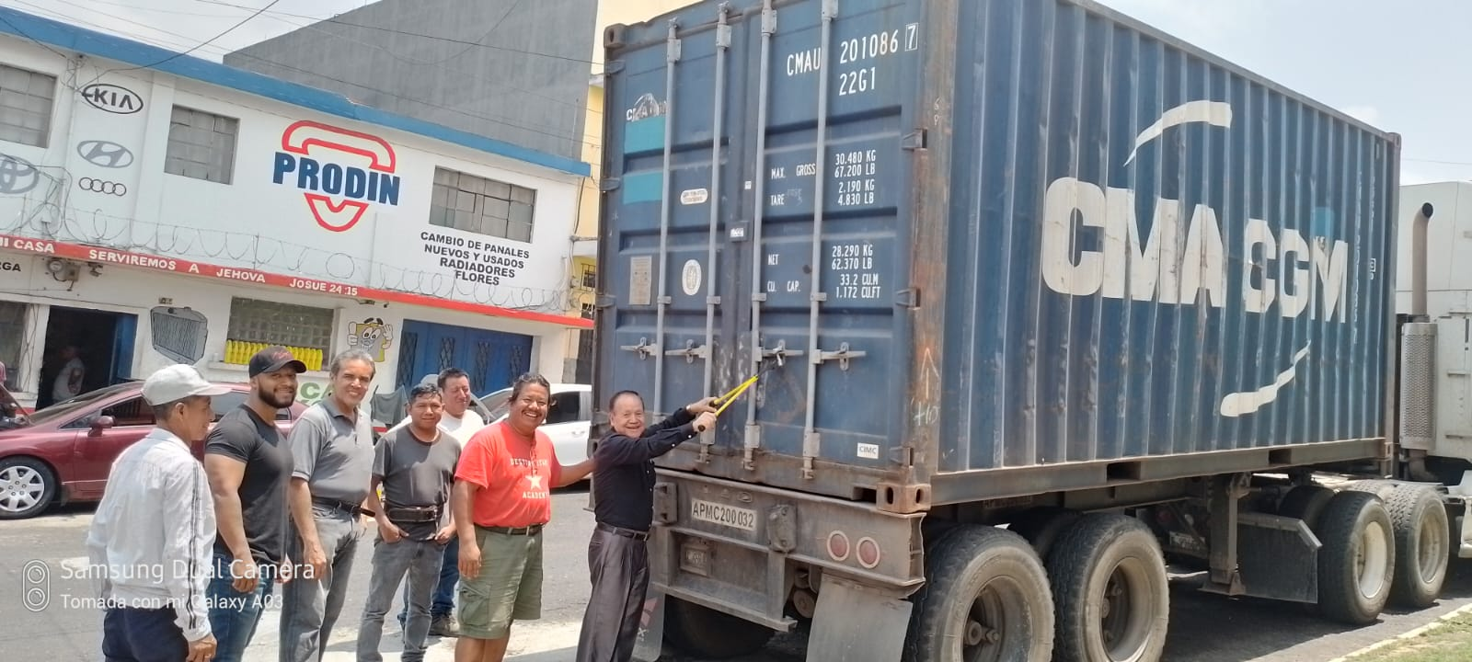

Yours in Christ,

Evan. Sid Madden

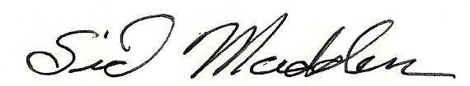

Ezekiel 33:1-6