May – June 2023

Dear Pastor and Friends,

We are writing you a few days early this time because we are leaving in just a few days for an **organizational trip to Guatemala**, and won’t be back home until after the first week of July. We wanted you up-to-date as to our work and especially wanted your prayers going with us as we make this trip. We have already delivered a container of Bibles, tracts, Roman’s booklets, etc. into the country, and the purpose of personally going to Guatemala is to work on organizing a scripture distribution center in this land of great need. We have a couple missionaries there who are willing to distribute the Scriptures, and want to help make this something more than a one-time thing. Pease pray with us that we can get this set up in such a way that the logistics can be done from here at our ministry base in the future. We have added some pictures of the Scriptures arriving in Guatemala to the end of this letter so that you can see what your investments are doing. I hope to get some more pictures from our trip to you with our next report.

Along this line of thought, it seems that we might have a door opening up for us to begin similar scripture distribution ministries in other countries in Central America. We now have our sights set on Honduras and Nicaragua as we already have contacts there who are interested in getting a scripture supply line going. I’m telling y’all about this now, so that we will have already spent time in prayer anticipating God’s provision in the near future.

Obviously, much greater resources are necessary for these endeavors. And our resources come from our Lord, through his people of course, but ultimately it is He who is the beginning and the end of all resource!

Our work in Mexico is not suffering while we work on these newer efforts. We are shipping out a load of approximately 1.2 million gospel tracts to a ministry in Cuauhtémoc, Chihuahua, Mexico. These tracts are going to be distributed among a large number of pastors throughout that part of Mexico, thereby reaching thousands of souls with a salvation message in areas we will never be able to get to in any other way! Serving our wonderful God is exciting! I can almost feel the thrill in heaven itself as many thousands of souls receive an opportunity to know and love our great God and Savior.

It goes without saying that **we continue to distribute many thousands of gospel tracts and booklets at the market every week**. The cost to rent our space at the market has gone up, but then need of the people has increased as well. We have been privileged to both do this work ourselves, and also to supply a number of others who are doing the same thing in other market ministries. It’s amazing to see so many people coming through the market, even though we’ve been experiencing near record high temperatures most every day. It has been over 100 degrees daily for quite a while now, and is projected to continue like this for some time yet, but the people keep coming, so we’ll keep going!

On the home front, we were enabled to complete the cement work on the entryway for our warehouse through the generous donations of God’s people. With this step completed, rainy weather won’t hinder us as we receive and ship truckloads of God’s Word. Next, we’ll be looking to expand our warehouse and add in a small office, bathroom and guest room. We have the space necessary, with the recent addition of the storage container, for what we’re doing at the present time, but with the constant growth of this ministry, I can see the need coming down the road very soon. **Please add all of what I’ve mentioned to your prayers**, and if you would, include prayers for the health of everyone involved, along with the need for workers, both here at the warehouse, the market minitry and everywhere we ship scripture to.

Many years ago, our Heavenly Father, the God of Israel, speaking through Moses told his people in Exodus 14:15, *speak unto the children of Israel, that they* ***go forward:*** In saying this, our Lord made clear his desire that he did not want his people to stop, or turn to one side or another. He very clearly said “go forward”! This my friends, is what we have been trying to do these many years now. God, being the gracious and merciful God that he is, has helped us, encouraged us, provided for us, and guided us all along the way! Each and every one of you dear friends, have been used by that same God to accomplish this! Your prayers, your faithful giving, and your evident love have been instrumental in our efforts to **move forward for our great King!**

Your missionaries,

Jack and Gloria Ferguson

Reaching into Mexico and beyond!

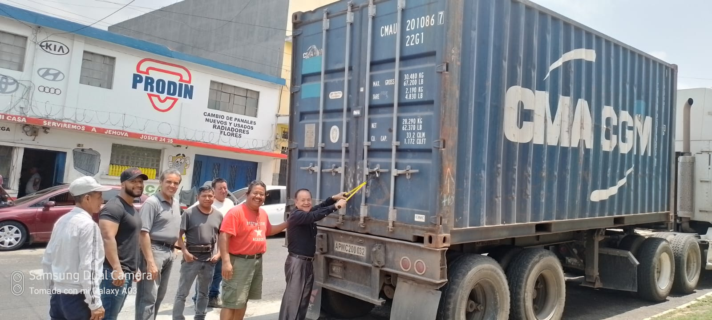

Scripture arriving in Guatemala City

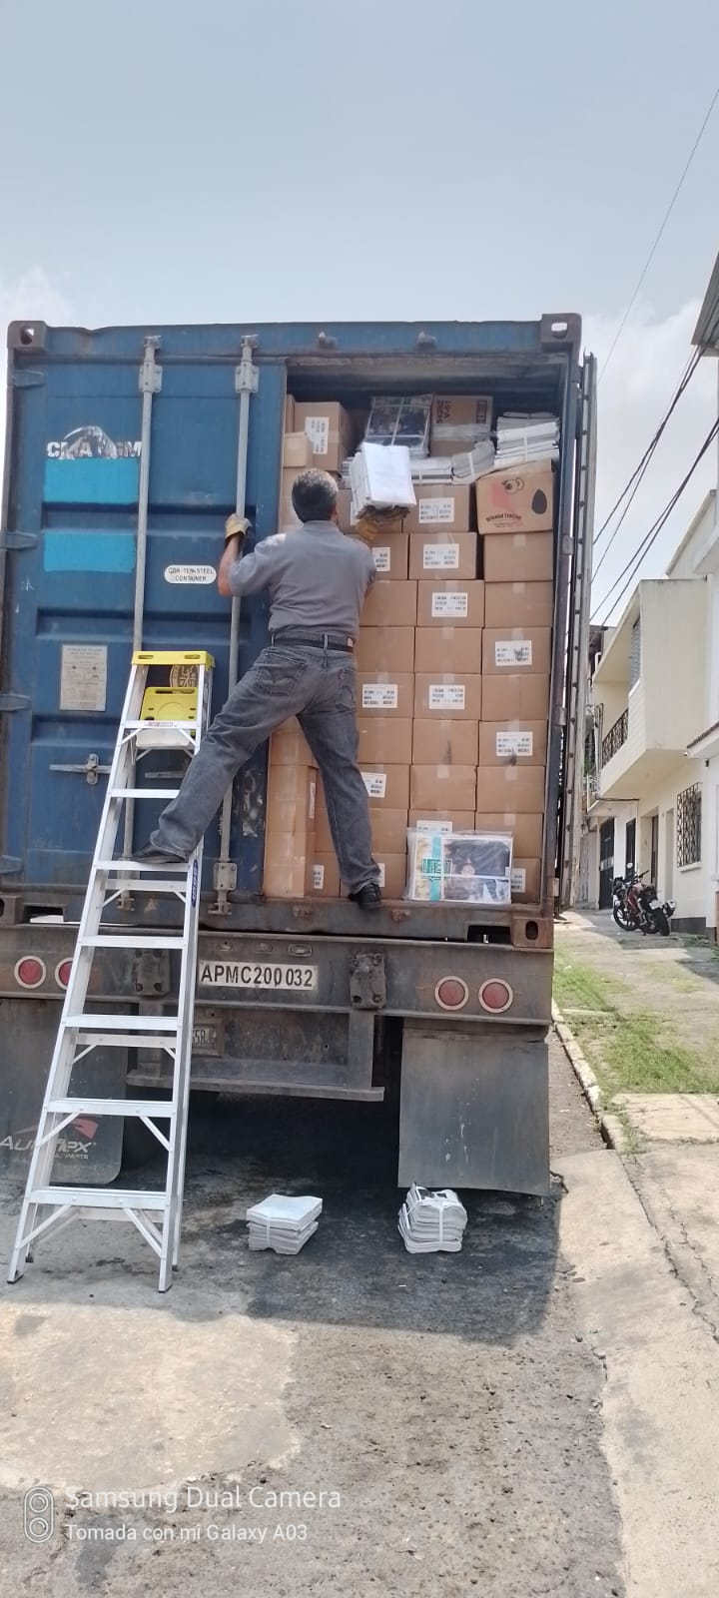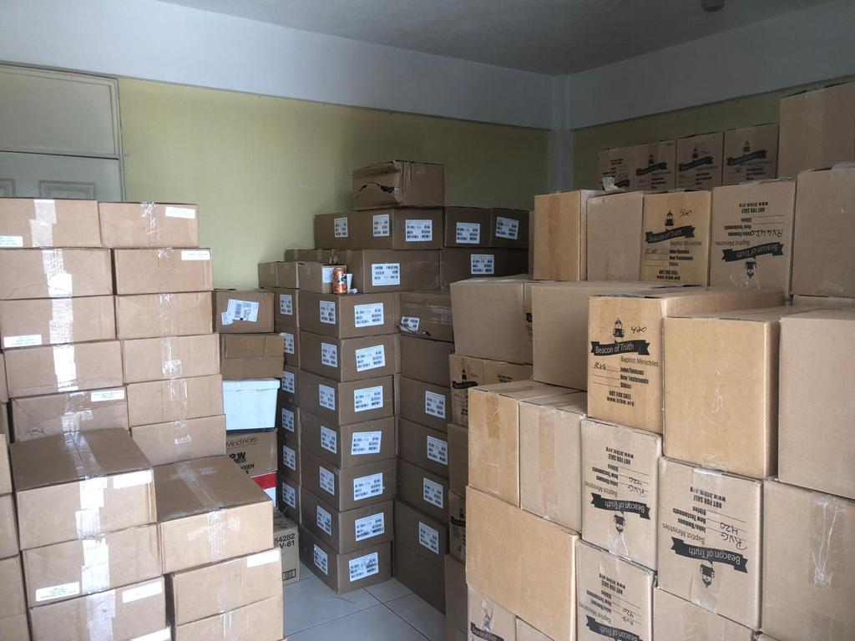

Unloading and organizing for distribution.